RETAIL DATA PLATFORM
Deliverable & Architecture
Data Model Documentation • ETL/ELT Design • Governance • Quality • CI/CD • Performance Benchmark Plan

Document Control | Value
Employee | Sankara Rao Chappa
Reporting / Performance Manager | L Raj Kumar Sabbavarapu
Review Session | 19-Aug-2026 – Data Model Documentation & ETL/ELT Design
Technology | Snowflake • Python • dbt • GitHub / GitHub Actions
Document Version | V1.0 – Review Ready
Evidence Basis | PIP document + Snowflake DDL + RAW/AUDIT DDL + retail platform draft + architecture PPT

1.Review Snapshot
The purpose of this section is to make the review outcome immediately visible: what has been designed, what is evidenced by supplied artifacts and what requires execution evidence at later checkpoints.
Dimension | Evidence Available | Readiness | Remaining Evidence
Requirement understanding | Business problem, scope, assumptions, use cases, architecture and design decisions documented. | READY | None for design walkthrough
Data model | RAW source model + dimensional model + explicit fact grains + SCD2 design. | READY | Optional executed row-count validation
Snowflake setup | Warehouses, database, schemas, RBAC, grants, resource monitor and PII tag DDL. | READY | Execution screenshot / SHOW output if available
ETL/ELT design | Python ingestion flow, audit/quarantine design, dbt layer design, incremental approach. | READY AS DESIGN | Python/dbt run evidence
CI/CD | GitHub/GitHub Actions architecture and intended test/build/deploy flow. | READY AS DESIGN | Workflow YAML + successful run evidence
Data quality | Validation, reconciliation, dbt tests and failure reporting design. | READY AS DESIGN | Actual test results
Performance benchmark | Metrics, benchmark dimensions, improvement of candidates and acceptance criteria defined. | PLAN READY | Actual runtime/credit/throughput measurements
Architecture review | PPT diagrams embedded in this document and demo narrative included. | READY | None

2.Requirements & Traceability
Requires high-quality deliverables, clear requirement understanding, end-to-end ownership, and consistent process/communication. It also specifies a sequence of technical milestones from Snowflake setup through architecture, Python ingestion, dbt, data quality, benchmarking and final architecture review.
Required Change / PIP Expectation | How This Package Addresses It
Deliver high-quality work | Consolidated architecture, data model, governance, ETL/ELT, quality and benchmark documentation with explicit evidence boundaries.
Understand requirements & business impact | Business problem, scope, downstream use cases, assumptions and design rationale are stated before implementation details.
Ownership & self-sufficiency | End-to-end platform design connects source, ingestion, Snowflake, dbt, analytics, governance and consumption.
Follow processes & communicate effectively | PIP traceability, demo agenda, speaking scripts, risks, evidence status and next actions are included.

3. Executive Architecture
The architecture is a governed retail data platform in which source CSVs are ingested into Snowflake RAW/AUDIT, transformed through dbt, exposed as an analytics star schema, and consumed by BI/reporting. GitHub/GitHub Actions provides version control and deployment control; Snowflake RBAC, PII tagging and resource monitoring provide governance.

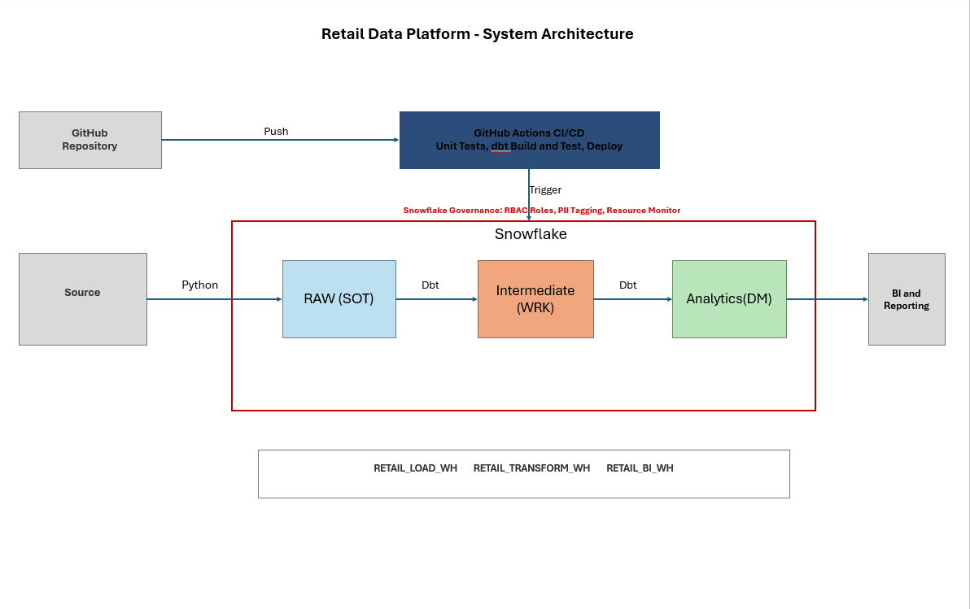

• Source: Six CSV extracts covering customer, product, store, order, order-item and inventory domains.
• Ingestion: Python performs file loading, validation, metadata capture and audit logging.
• Storage: RAW preserves source data, while AUDIT captures ingestion runs, errors and rejected records.
• Transformation: dbt processes data through STAGING and INTERMEDIATE layers using cleansing, deduplication, joins and business rules.
• Analytics: ANALYTICS provides the curated dimensional model with business-ready facts and dimensions.
• Consumption: BI and reporting tools consume the governed ANALYTICS layer.
• CI/CD: GitHub Actions supports automated testing, dbt build/test and controlled deployment.
• Governance & Compute: Snowflake RBAC, PII tagging, resource monitoring and separate warehouses provide security, governance and workload isolation.

3.1 End-to-End Flow
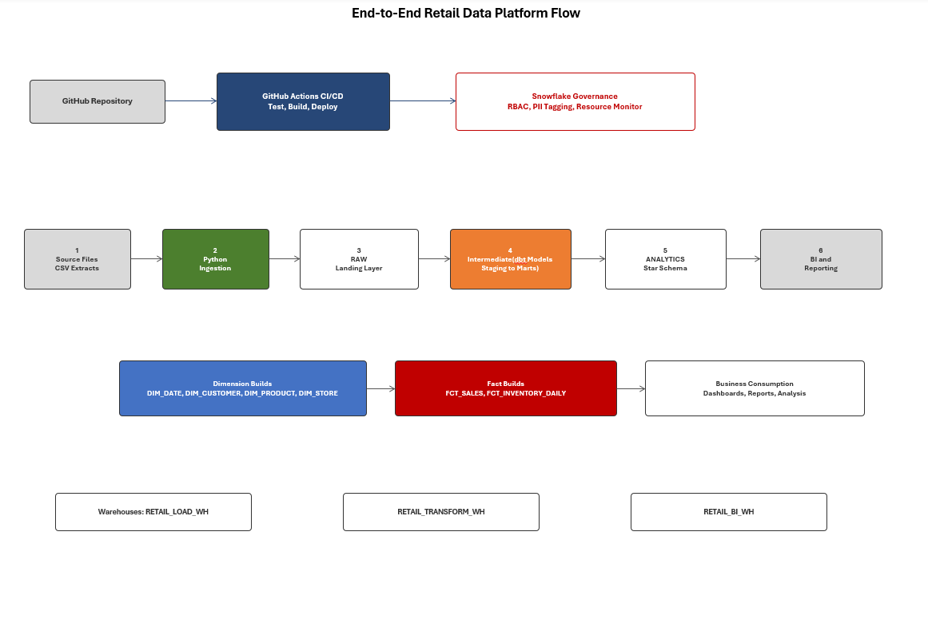

Step | Stage | Key Responsibility
1 | Source Files | CSV extracts from retail business domains
2 | Python Ingestion | Validate, load and capture metadata
3 | RAW | Preserve source outcomes
4 | dbt Models | Standardize, transform and build marts
5 | ANALYTICS | Curated star schema
6 | BI / Reporting | Business consumption and analysis

4. Business Problem, Scope & Outcomes

4.1 Business Problem
- Retail organizations generate operational and analytical data across customers, products, stores, orders, sales transactions and inventory.
- Fragmented source systems can create inconsistent reporting, data silos and limited business visibility.
- The platform centralizes governed processing and delivers analytics-ready models for trusted reporting.

4.2 Business Outcomes
Outcome | How the Platform Delivers It
Standardization | Common curated dimensions/facts and controlled transformation layers
Faster reporting | Analytics-ready star schema and workload-isolated BI warehouse
Governance | RBAC, PII classification and controlled resource usage
Scalability | Snowflake compute separation and layered transformation architecture
Historical analysis | Customer Type 2 SCD history and daily inventory snapshots

4.3 In Scope
- Snowflake environment and workload-specific warehouses
- RAW, STAGING, INTERMEDIATE, ANALYTICS, SNAPSHOTS and AUDIT schemas
- Six source CSV domains
- Python ingestion and audit/rejection framework
- dbt transformations, incremental processing and snapshots
- Analytics star schema
- RBAC, PII tagging and resource monitoring
- CI/CD architecture
- Data quality and reconciliation framework
- Performance benchmark framework and improvement options

5. Snowflake Platform Design
Object | Purpose | Evidence
RETAIL_LOAD_WH | Python ingestion workload | DDL supplied; XSMALL; auto-suspend 60s
RETAIL_TRANSFORM_WH | dbt transformation workload | DDL supplied; SMALL; auto-suspend 60s
RETAIL_BI_WH | BI / analyst workload | DDL supplied; XSMALL; auto-suspend 300s
RETAIL_DB | Retail analytics database | DDL supplied
RAW | Untouched source landing | DDL supplied
STAGING | Light cleaning/casting/renaming | DDL supplied
INTERMEDIATE | Joins, deduplication, business-rule preparation | DDL supplied
ANALYTICS | Fact/dimension business mart | DDL supplied / draft documentation
SNAPSHOTS | SCD2 history | DDL supplied
AUDIT | Run logs and rejected records | DDL supplied

5.1 RBAC
Role | Intended Responsibility | Access Design
RETAIL_LOADER | Python ingestion | RAW/AUDIT only; no ANALYTICS access
RETAIL_TRANSFORMER | dbt | Reads RAW; owns STAGING/INTERMEDIATE/ANALYTICS/SNAPSHOTS
RETAIL_ANALYST | BI/reporting | Read-only ANALYTICS
RETAIL_ADMIN | Platform administration | Full RETAIL_DB control; manages functional roles

5.2 Governance
- A shared resource monitor is configured across the three warehouses with a monthly credit quota and notification/suspend thresholds.
- A PII_CLASSIFICATION tag is defined for column-level PII classification.
- Customer PII fields are intended to be governed at the analytics layer.
- Functional roles are separated so ingestion, transformation and BI workloads do not share unrestricted privileges.

6. Source Data Model & Relationships
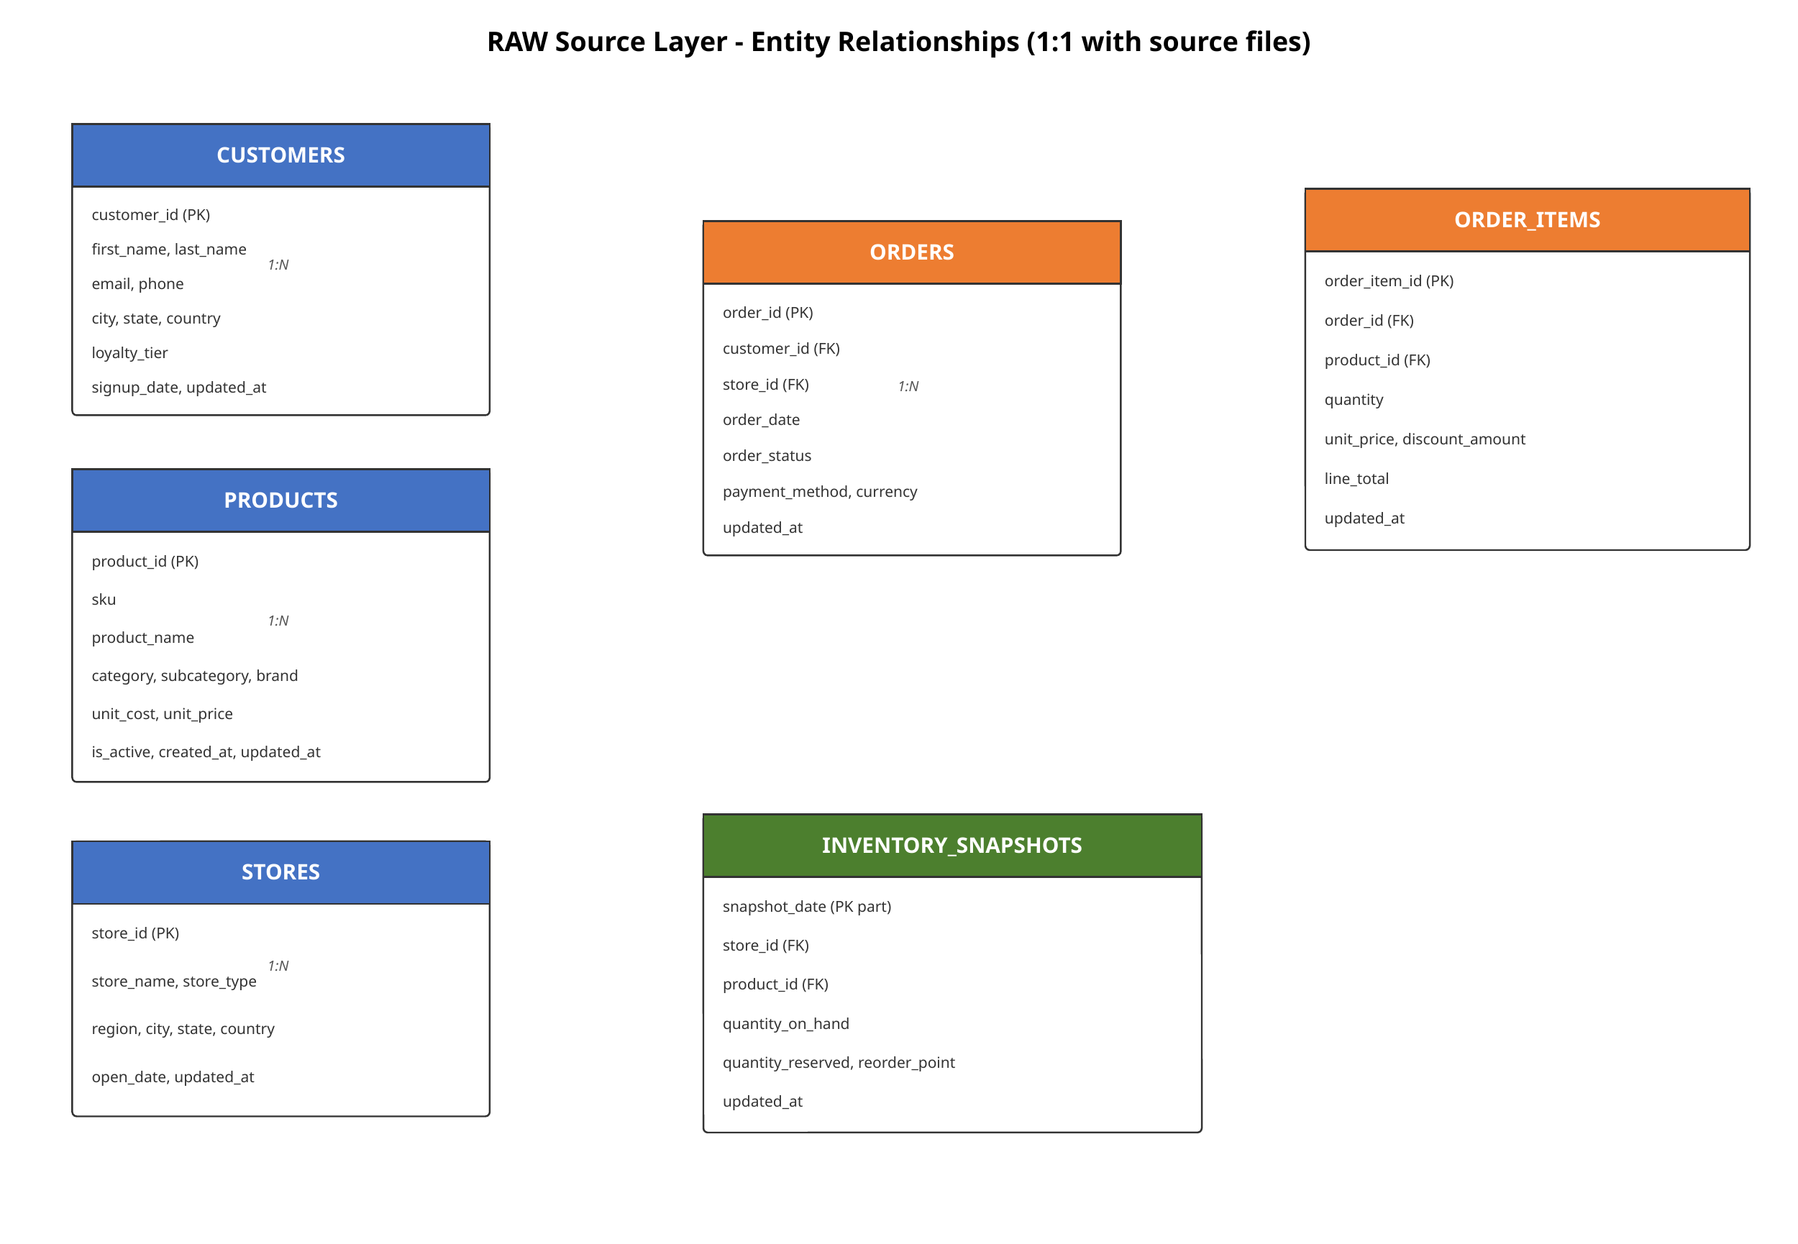
RAW Table | Business Key | Key Data
RAW.CUSTOMERS | customer_id | Customer identity/contact, geography, loyalty tier, signup/update timestamps
RAW.PRODUCTS | product_id | SKU, product/category/brand, cost/price, active status
RAW.STORES | store_id | Store identity/type and geography
RAW.ORDERS | order_id | Customer/store, date, status, payment method, currency
RAW.ORDER_ITEMS | order_item_id | Order/product, quantity, price, discount, line total
RAW.INVENTORY_SNAPSHOTS | snapshot_date + store_id + product_id | On-hand, reserved, reorder point

- CUSTOMERS → ORDERS: one customer can have many orders.
- ORDERS → ORDER_ITEMS: one order can contain many order lines.
- PRODUCTS → ORDER_ITEMS: one product can appear on many order lines.
- STORES → ORDERS: one store can receive many orders.
- STORES + PRODUCTS + DATE → INVENTORY_SNAPSHOTS: daily inventory position.

7. Medallion / Layered Architecture
Layer | Purpose | What should NOT happen here
RAW | Preserve source structure and ingestion metadata | No business-rule transformations
STAGING | Casting, naming cleanup, light standardization | Complex business logic
INTERMEDIATE | Joins, deduplication and business-rule preparation | Direct BI consumption
ANALYTICS | Business-ready facts and dimensions | Raw source preservation
SNAPSHOTS | Historical SCD2 state | General-purpose reporting
AUDIT | Operational observability and rejected records | Business analytics

8. Dimensional Model & Fact/Dimension Processing
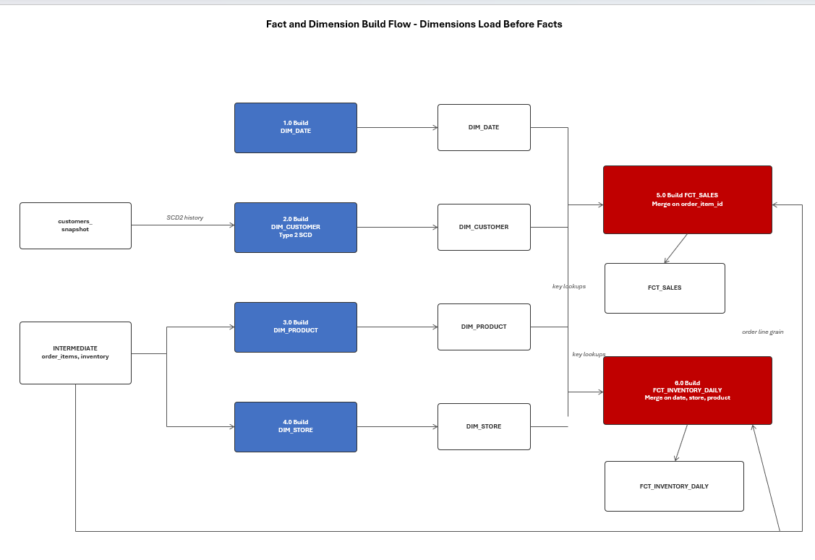

8.1 Dimensions
Dimension | Business Purpose | Important Design
DIM_DATE | Time-based reporting | date_key plus calendar/fiscal attributes
DIM_CUSTOMER | Customer behavior / loyalty | Natural key + surrogate key + SCD2 history
DIM_PRODUCT | Product/category analysis | Natural key + surrogate key + product attributes
DIM_STORE | Store performance | Natural key + surrogate key + store attributes

8.2 Facts
Fact | Declared Grain | Metrics / Attributes
FCT_SALES | 1 row per order line | Quantity, unit price, discount, line total, unit cost, gross margin; date/customer/product/store keys
FCT_INVENTORY_DAILY | 1 row per store + product + day | On-hand, reserved, available, reorder point, below-reorder indicator

Key design decision
Dimensions are built before facts because fact loads require dimension key lookups. DIM_CUSTOMER uses Type 2 SCD history so historical customer attributes remain analyzable over time.

9. Analytics Star Schema
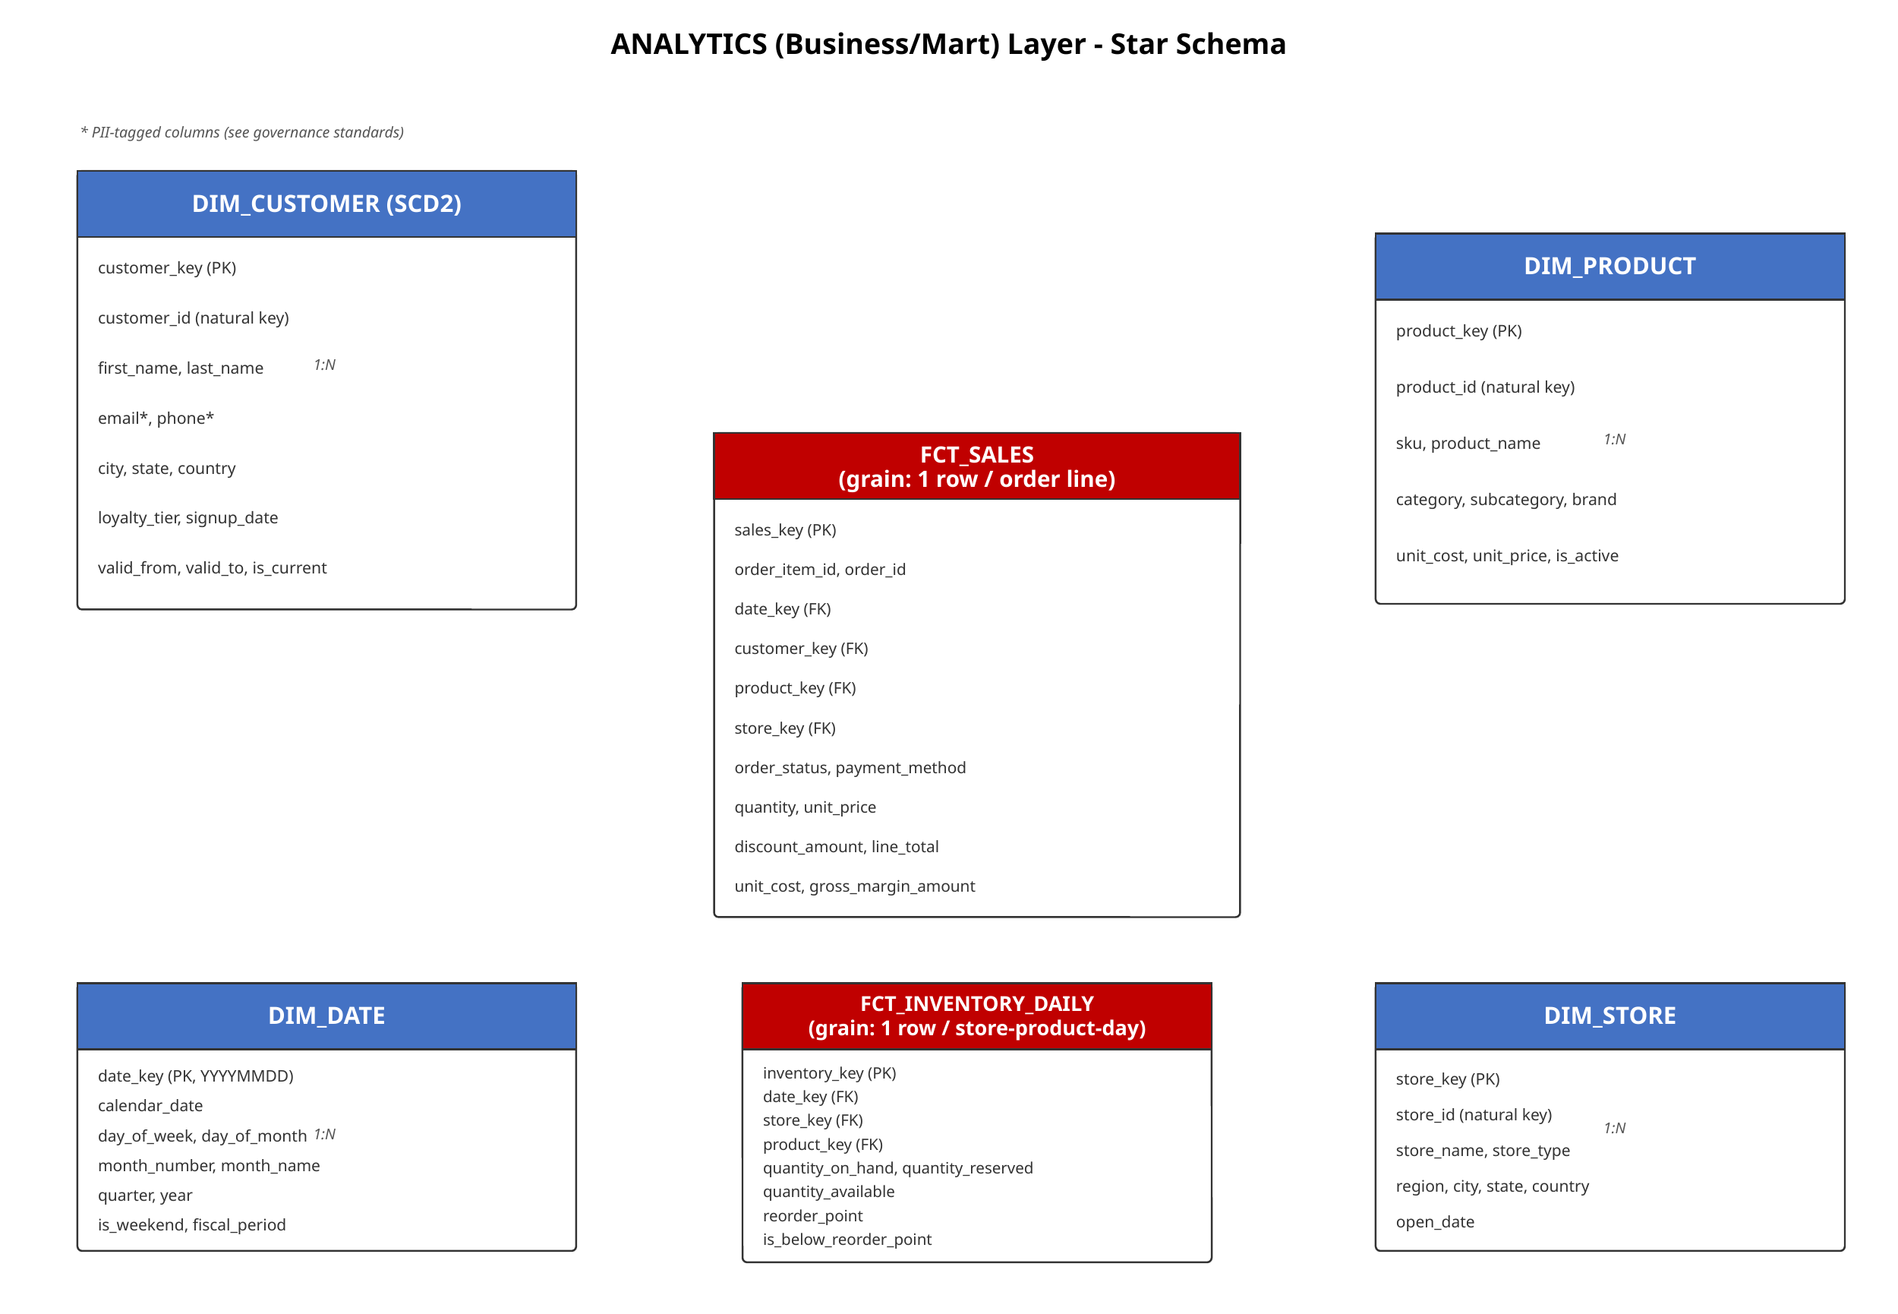

The analytics layer separates descriptive dimensions from measurable facts. This structure is intended to make reporting easier to understand and to provide stable business grains for KPI calculations.
Model | Grain / Role | Example Analysis
DIM_DATE | Date context | Daily/monthly/quarterly/year reporting
DIM_CUSTOMER | Customer context + history | Loyalty, segmentation and customer behavior
DIM_PRODUCT | Product context | Category, brand and product performance
DIM_STORE | Store context | Store/region performance
FCT_SALES | Order-line events | Revenue, quantity, discount, margin
FCT_INVENTORY_DAILY | Store-product-day snapshots | Availability, reorder and stock monitoring

10. ETL / ELT Design

10.1 Python Ingestion
Stage | Expected Behavior | Failure Handling
Discover | Identify source files and create batch/run identifiers | Fail run clearly if expected file is missing
Validate | Schema + record validation | Invalid records go to quarantine
Load | Write accepted records to RAW | Track loaded count
Audit | Write one run-log record per file/batch | Status SUCCESS / FAILED / PARTIAL
Reconcile | Compare read/load/reject counts | Raise discrepancy for investigation
Recover | Preserve error context for rerun | Do not silently discard failures

10.2 AUDIT Structures
Table | Purpose | Key Fields
AUDIT.INGESTION_RUN_LOG | One row per file/batch attempt | batch_id, source_file, target_table, start/end, status, rows read/loaded/rejected, error
AUDIT.REJECTED_RECORDS | Quarantine invalid records | batch_id, source_file, target_table, raw_record, validation_error, rejected_at

10.3 dbt
- STAGING: 1:1 with RAW; light cleaning, casting and renaming.
- INTERMEDIATE: joins, deduplication and business-rule preparation.
- ANALYTICS: curated facts and dimensions for BI.
- SNAPSHOTS: Type 2 customer history.
- Incremental fact processing: use a controlled watermark/change criterion so only new or changed records are processed.
- Reusable macro approach: centralize incremental filtering logic rather than repeating it across fact models.

11. Data Quality, Reconciliation & Observability
Check | Expected Rule / Evidence
Schema | Expected columns and compatible types exist before processing
Business keys | Customer, product, store, order and order-item identifiers satisfy uniqueness expectations
Referential integrity | Orders resolve to customers/stores; order items resolve to orders/products
Fact grain | No duplicate order-item rows in FCT_SALES; no duplicate store-product-day rows in inventory
Measures | Quantity/price/discount/line total are valid and reconciled
SCD2 | Customer history has coherent valid_from/valid_to and current-row behavior
Reconciliation | Rows read = rows loaded + rows rejected, subject to documented exceptions
Failure reporting | Run status and error details persist in AUDIT
dbt tests | Schema, uniqueness, relationships and custom business tests

12. CI/CD & Engineering Workflow
GitHub push → GitHub Actions → Unit Tests → dbt Build/Test → Deploy
- Version-control Snowflake DDL, Python ingestion code and dbt models.
- Use automated checks before deployment.
- Run dbt build/test to validate model dependencies and data quality.
- Deploy only approved changes.
- Retain pipeline history for traceability and troubleshooting.

